Volume 60, Issue 3 Spring 2026

April 2025


The Cortland Cause

A year reflected, a year ahead
In Solidarity, Justin Neretich, Cortland Chapter President

I am approaching the end of my first year as Cortland UUP Chapter President, and I have some thoughts on the journey and the road ahead that I’d like to share with you all. Despite my knowledge of the trials and tribulations that come with this role, as well as the tremendous support received from our other chapter leaders including our previous president, I am still amazed at how much goes into organizing, engaging with, and supporting our members. Oftentimes the learning on the job coupled with hearing about some hard challenges that individual members were facing, and it was through this context that I really began to understand how critical the union was to our everyday lives, even if we might not know it. Our campus is a delicate eco-system of work that on the surface may feel separated and siloed, but in reality is connected by roots underneath, and when even one area is experiencing a problem, it reverberates out across the root network, under our feet. We’ve grown so accustomed to working on unsteady ground that I think it is hard to recognize that we have systemic problems.

There have also been times that the ground was solid beneath us; events were hosted and attended, discussions were had in labor management, decisions were reached to help members navigate their needs, and more members recognized that service to our Union is service to the institution. This gives me hope for what lay ahead. The building blocks of strong organizing start with 1:1 conversations, and I have an aggressive goal of meeting with each and every member starting this summer session and continuing through next Spring. I am optimistic, and think that we can respond to four simple questions:

- What’s one great thing going on in your area/department?
- What’s one thing that would improve your work/life balance?
- Who’s someone you trust and respect on campus?
- Would you ask these questions to two or three of your colleagues?

These responses help us to build our capacity to bring issues to the table and get the right people sitting at the table. They’ll also spark creative ideas and solutions to problems we continue to tackle. It won’t be easy, and it certainly won’t be perfect, but I envision all the ways it may advance our solidarity around campus, as our chapter continues to evolve to meet the needs of an uncertain professional landscape, and face the hostility of external pressures to belittle the power of education, of academic freedom, and of our ability to expand our communities with empathy, equity and a justice governed by laws and policies, of which we strive to right. Our union power is also political power, and it will be needed in order to have a say at the table as Cortland also evolves to meet the needs of our community.

In Solidarity,
Justin

Cortland Works 2026
Photos by David Ritchie

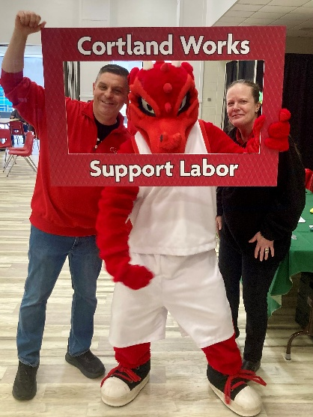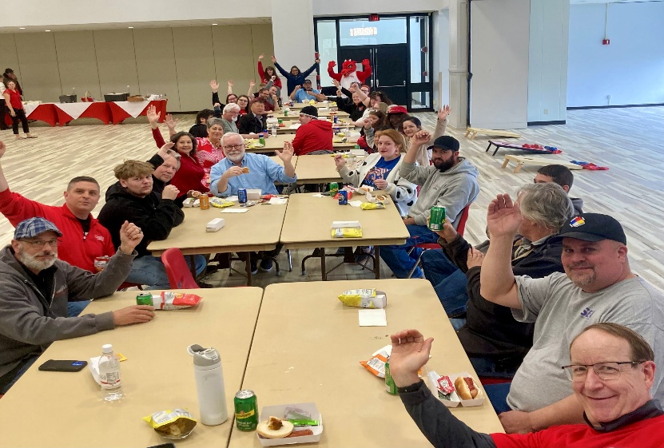

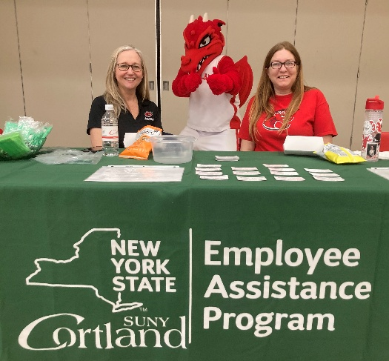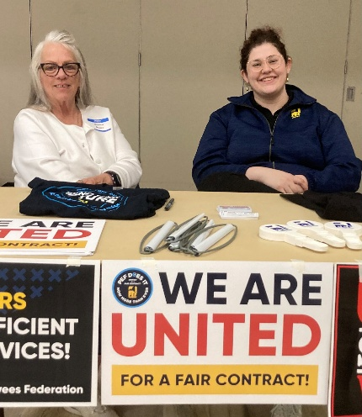

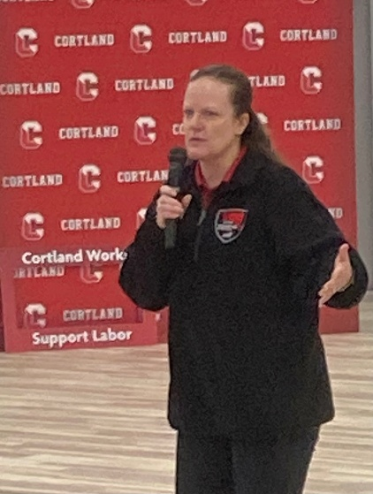

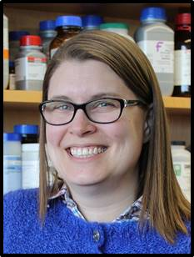
A snapshot of my annual report
By Christa Chatfield (UUP Cortland DEI Officer)
In starting to work on my annual report I find myself proud but also a little shocked at how much work I did in Fall of 2025! Bear with me as I share that information here. I listed eleven separate CRN (Course Record Numbers) on my annual report.
- I got paid for one credit of extra service for those eleven courses (to teach one section of COR 101 and the accompanying Student Facilitator class).
- Of the other nine CRN, two are duplicates (a split section for one lecture that had seats for both majors within my department, and students from other majors). That leaves seven more if you are following along.
- Two of those seven are the lab sections for my lectures.
- Two of those remaining five are for my research students, as they were at different levels of their progress in their projects there were in two different courses.
- That leaves three CRN that cover internships that I supervised for my advisees at two locations (the local ED department and at a hospital in Syracuse).
It’s a total of 72 students with a total of 108 “seats” (the students in the lecture and lab took up two seats each). It’s a total of 13 credit hours earned by students across those eleven courses (again with pay for only one credit of extra service).
I apologize if this listing seems boring, pedantic or rote, but I wanted to take a chance to share this outside the small chain of admin who will see this report. I know many faculty are carrying more than I am in terms of students taught per semester and even in CRN listed on their reports.
I am proud not only of myself but of my fellow faculty and the work we do here for serving students in so many ways. So much of this work feels hidden since it doesn’t count for my “nine credit” hours per semester. But I know the students appreciate my efforts and it leads to key professional training in research and real-world work that they get college credit for learning. This is transformational learning I value. Should I say no to these internships and research students? It’s no simple thing to turn away students who need internship credits for their degree (in the case of at least two majors in my department). In the case of the research mentoring, it is an expected part of my job as defined by my department. While I might find joy in that work, my labor feels invisible, as it is uncompensated. I know there are also professional faculty out there in UUP who are feeling similar burdens of additional responsibilities which may or may not lead to extra service. Thank you everyone for reflecting with me on the complex web of job responsibilities even just in this one section of my annual report.

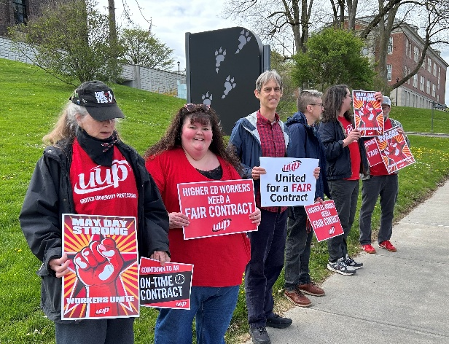

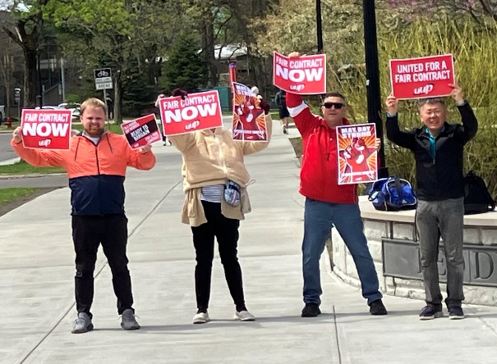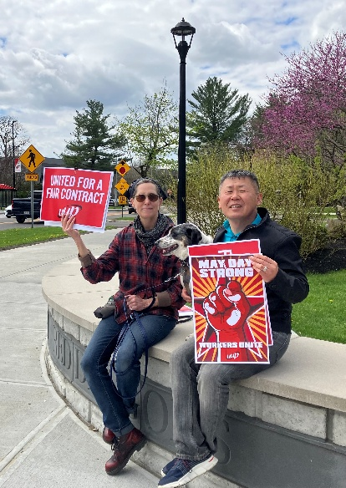

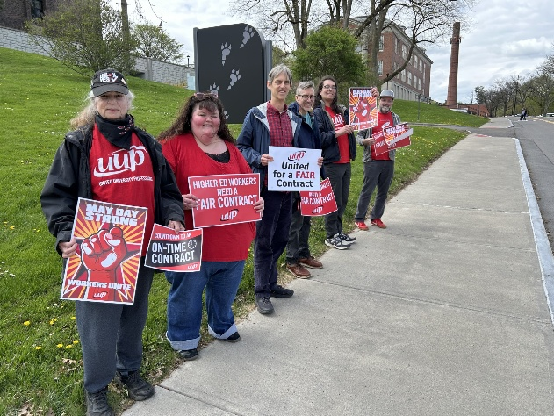
May Day Photos by Dave Ritchie and
Ross Borden

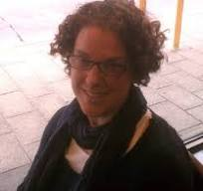
The Call is Coming from Inside the House:
Administrative Erosion of Academic Values
By Kristine Newhall, Vice President for Academics

The day I began drafting this piece, Yale University released its report on problems facing higher education in the United States. The report provides an effective lens through which to examine the past year at Cortland.
We continue to hear, in education publications as well as from our administration in open meetings and fora, that the public no longer trusts higher education and thus no longer values it as highly. And while the “enrollment cliff” dominates the discourse, the public perception of education is part of the discussion. The Yale report concluded that this is—in part—because of administrative and bureaucratic endeavors that lack transparency and are confusing. I note here that these are largely things faculty—academic and professional—do not control but are deeply affected by.
Let’s keep the Yale report in mind as we transition into what I predict will be an impactful summer for our institution. This is the moment the outside consulting group, Gray Decision Intelligence, is expected to do significant work. Hired to create a dashboard to determine—according to the Request for Proposals—where we can grow our academic offerings, many I have spoken with are skeptical of this mission. Our colleagues at other institutions who have been subject to program review—including by this same company—have shared their negative experiences including retrenchment and decisions made on inaccurate data.
This is an example of the transparency issues we will be facing. What AI models is this company using? What data? Because their methods are proprietary, will we ever know how decisions are being made? (I mean, rumors abound about why the paper towels were taken away so skepticism about this is not unwarranted.) We must be ready to ask questions and demand accurate information.
The issue of transparency extends into other areas as well. I applaud everyone who continues to ask probing questions, including at the Provost’s open meeting earlier this month. Where is this data coming from? We heard about the extra services budget, but this is just one piece of the budget. What about the operating budget and expenses? When we cannot see the bigger picture, we are excluded from the conversation about institutional priorities and goals. But Cortland is not alone in enacting this dynamic.
The Yale report also cites as problematic, changes that are top-down and marked by micro-management, brand management, and expansion of the bureaucracy itself. (Coming in the fall: data from the Academic Concerns Committee’s Ad Hoc Research Group that has been looking at hiring trends and salaries.) These are not faculty-led and often not faculty endorsed. For example, this administrative turn in higher education affects ways in which enrollment and retention are managed. Some of us have seen large, often unmanageable growth in programs, because that growth has been uncontrolled and unplanned. This is happening at the undergraduate and graduate level. And it is, in part, responsible for the financial stress on the extra services budget. More PE students equals more expense for student teacher supervisors. More graduate students means more sections of courses that need to be covered. We are doing more with less but being told to simply do less: fewer tests or assignments, for example, in overenrolled or increased caps courses. The effects of this are wide-ranging. Faculty—academic and professional—morale is damaged. Students who are experiencing mental health issues are less likely to be noticed in a class that has 80 students in it. Research has shown that student engagement in courses diminishes the larger the class size. This affects our ability to teach critical thinking. Ultimately it will affect the ability of some programs to be successfully accredited.
By the time this is published, graduation will be over; a few balloons stuck in the rafters at Park Center just remnants of the celebrations. The decision of faculty to attend is individual. But the dwindling number who do is

a sign. If you want the pomp and circumstance, then there needs to be a transparent and ongoing commitment to academic values—including valuing and respecting the labor of those who are trying to uphold them.

https://weartv.com/news/local/psc-accused-of-censoring-student-journalists-after-lgbtq-stories-pulled-from-magazine
The Love That Dare Not Speak Its Name 
by Nancy Kane, SUNY Cortland Executive Board Member-At-Large

In 1892, Lord Alfred Douglas published Two Loves, a poem in which the last line mentioned “the Love that dare not speak its name.” This phrase referred to his homosexual love for Oscar Wilde and was used in Wilde’s 1895 trial for gross indecency. Despite more widespread acceptance of the LGBTQIA2SP+ community in the United States, especially in the past two decades, a backlash is restricting college students’ First Amendment rights in some red states. The use of that poem and its context is going to be prohibited in some institutions of higher learning, thanks to ever-expanding incursions into free speech on college campuses.
Florida’s "Stop WOKE" Act (House Bill 7), was signed in 2022 by Governor Ron DeSantis. In May of 2026, college students at Pensacola State’s journalism and graphic design departments were blocked from publishing Born for the Spotlight: The Rise of Vixen Valentine (about a drag queen, written by Quincy Kirn) and Queer Stories Rolling Forward (by Liliana Rollins) in a new arts and culture magazine. Based on the Stop WOKE Act, Dr. Brenda Kelly, associate vice president of academic affairs, pulled the university’s financial support of the publication because of the mentions of LGBTQ+ topics. A local bookstore may publish the magazine, but this controversy highlights the ongoing suppression of free speech in the state (https://weartv.com/news/local/psc-accused-of-censoring-student-journalists-after-lgbtq-stories-pulled-from-magazine).
Meanwhile, in Texas, a memo by Chancellor Brandon Creighton to the Texas Tech system forbids discussing, teaching, and researching (including graduate theses and dissertations) anything to do with LGBTQ+ issues. Contextual information about identity in a wide variety of topics will be severely curtailed. For example, how can history professors completely ignore Stonewall and the AIDS crisis? How can English professors explain Oscar Wilde’s life story, or the subtext in Virginia Woolf’s (or Walt Whitman’s, Shakespeare’s, or many other authors’) writings? How does a political science professor discuss landmark Supreme Court cases on same-sex marriage? How could a psychology professor correct a student’s assertion that transgender people are mentally ill without reference to the removal of transgenderism from the DSM? The restrictions also include a Two Human Sexes Requirement, which forbids discussion of sex and gender beyond acknowledging that there are two human sexes. The existence of intersex conditions is permitted on a severely limited basis. Plans are in place to swiftly cut programs that include teaching about gender and sexuality issues, with recommendations due to the Chancellor’s office by mid-June, 2026. Artificial Intelligence is being used to scan course materials to target perceived violations (https://truthout.org/articles/texas-tech-establishes-draconian-new-censorship-policies-on-lgbtq-topics/).
The implications for academic freedom of faculty at Texas Tech and at Florida’s colleges and universities are obviously profound. Politicians imposing radical censorship are giving states the power of laws to force administrators to squelch free inquiry and discussion in higher education when the topics are considered controversial. Previously, pernicious restrictions on free speech were opposed by faculty organizations and free speech advocates. Now, however, the discriminatory and repressive silencing of faculty and student voices raised in sexuality and gender diversity discussions brazenly flouts academic and constitutional norms. We cannot ignore this overreach.

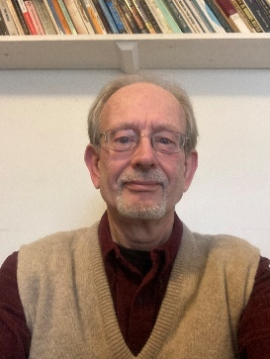
Cortland Retiree Brunch, April 20, 2026
By Dave Ritchie, Officer for Retirees

Garnets in the Adirondacks - A Deep Look Found Interesting Nano Minerals

While snow flurries made a return on April 20, Cortland UUP retirees at the Spring Retiree Brunch heard an engaging story by geology professor Bob Darling about recent discoveries of microscopic- and nanoscopic-size minerals INSIDE garnet crystals found in the Adirondacks and at a few other sites in the world. Covering geologic eons in an understandable way, Darling showed that the Adirondacks are part of a large igneous rock formation that covers much of eastern Canada on the north side of the St. Lawrence River.



Describing his collaboration with geologists from Italy and Germany, Darling shared some of the excitement, and the work, that went into discovering these tiny new metastable minerals in the Adirondacks that are versions related to the stable minerals quartz and feldspar, which make up the majority of the earth’s crust.

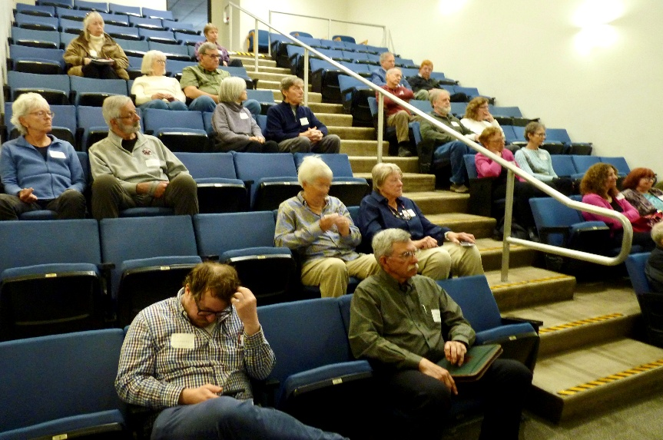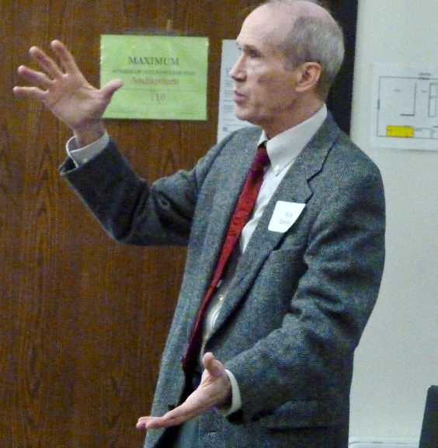

This Spring we tried a different arrangement of events, putting the presentation before brunch while still starting with the traditional meet & greet welcome, introductions, and UUP Benefits update. Speaking of the update, Dan Quackenbush from UUP Benefits pointed out the popular Travel Assist Service from MetLife, which is useful for travel assistance as near as 100 miles from home, and is purchased by the UUP retirees group so that we retirees get the service without added charge. NOTE: Retirees can get that brochure & card from the UUP Office.

Brunch featured a hearty vegetable stew, pulled chicken (which attendees could opt to add to the stew), a great fruited salad, with cooked quinoa and steamed broccoli providing additional protein and vitamin C. Dessert was a delicious peach-blueberry cobbler – vanilla ice cream optional! This table with Wayne (Information Resources) and Gretchen Douglas (Library), Julie Lenhart (Athletics), and Andy Young (Recreation, Parks, & Leisure Studies) was the one table where the members weren’t chewing when I took their picture. Oh, now I see why – they hardly had any food left on their plates to eat!

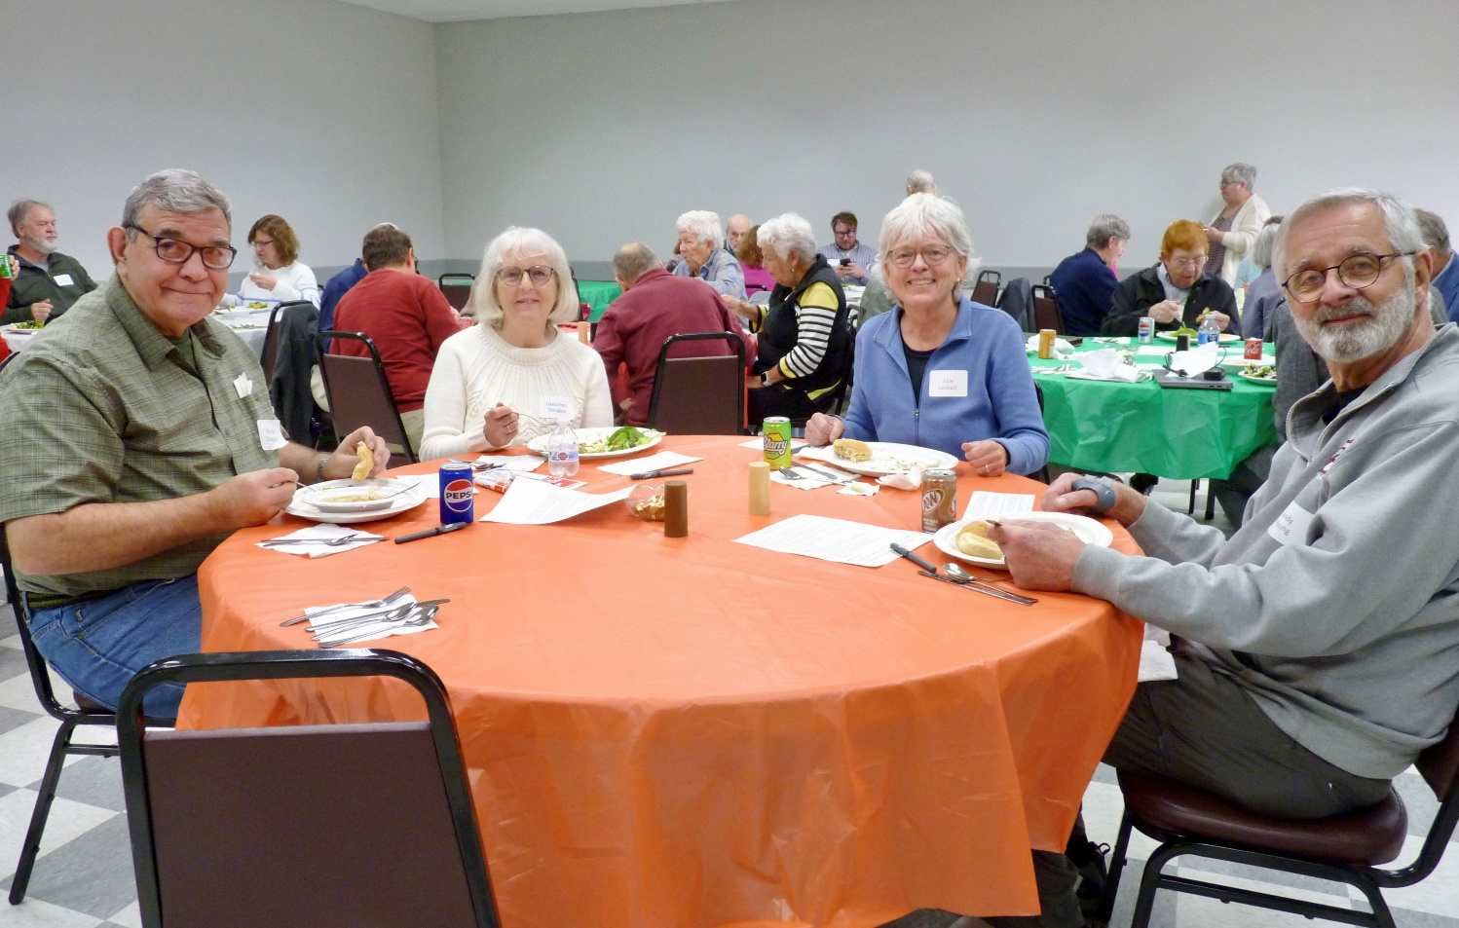

SURVEY RESULTS: Because this retiree event piloted a different arrangement – earlier start times, with the presentation before the brunch – I surveyed the attendees about the changes. I ignored the comments of “Who prepared this survey?” that were heard during distribution, but those derogatory comments were deserved because I gave respondents a middle choice (“either is ok”) instead of forcing a preference, so most of the questions with that option don’t show much difference in results. n=21, which was 81% of the retirees attending.
(a) The one clear result was that having the presentation BEFORE brunch was preferred:
13 before, 3 either is ok, 5 after. But these didn’t deliver clear results:
(b) Would you prefer an 11am start instead of 10:30, even though it means moving brunch back to 12:30pm? 8 prefer 11am, 7 either is ok, 6 prefer 10:30am.
(c) What day(s) of the week are best for you for this retiree get-together?
18 Monday, 15 Tuesday, 17 Wednesday, 16 Thursday, 11 Friday, 1 Saturday!
I did get some fine ideas for the Fall Retiree event! Watch for it. -- Dave Ritchie

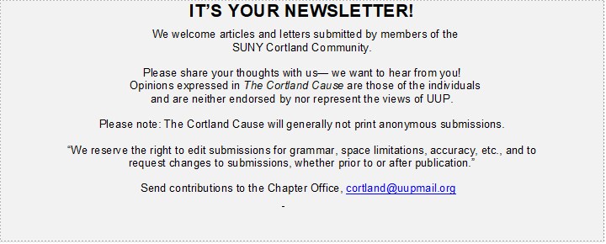

In Memoriam

Bruce Atkins (English)
Elizabeth Owens (Communications)
Dennis Selzner (LRS)

UUP CORTLAND SERVICE ANNOUNCEMENT

Remember that any technology such as laptops, tablets, mobile phones or other property of the campus can be taken back by the campus at any time. UUP advises that all members back up their own files on personally owned devices.

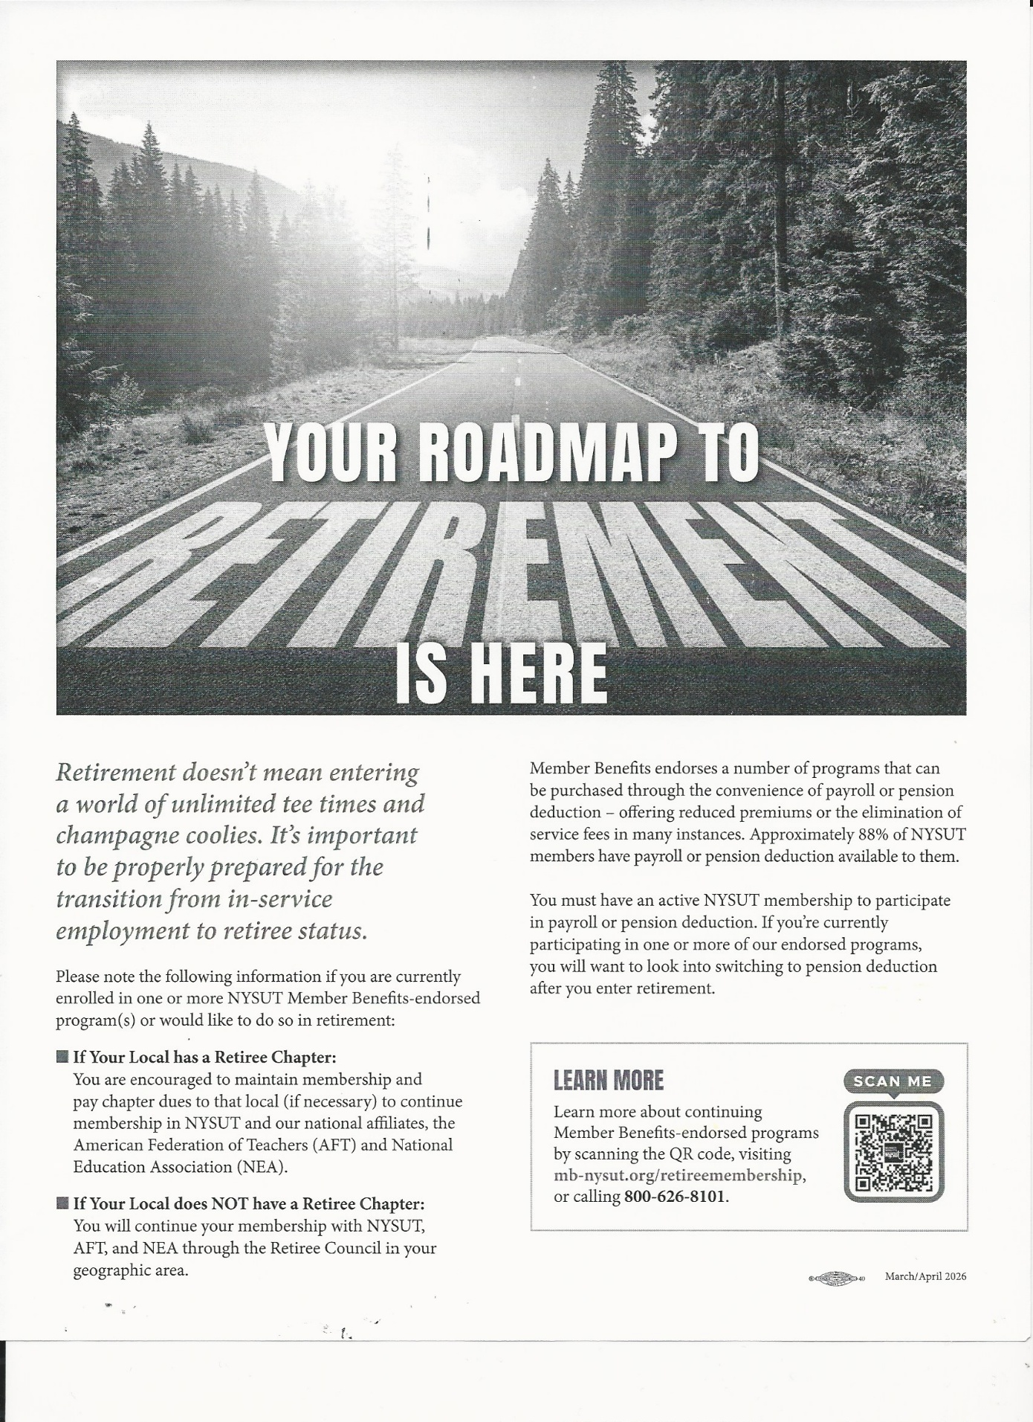

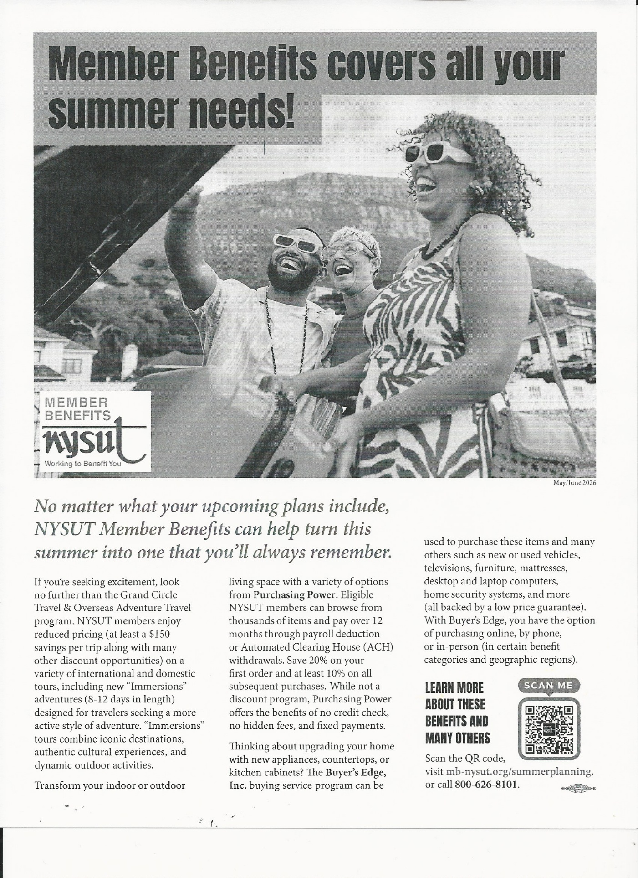
UUP CORTLAND CHAPTER — EXECUTIVE BOARD 2025-2027

4-Digit phone numbers begin with 607-753-xxxx

OFFICERS
PRESIDENT: Justin Neretich (Community Engagement and Academic Coord.) 5772 jneretich@uupmail.org
VICE PRESIDENT for ACADEMICS: Kristine Newhall (Professional Studies) 4357 kristine.newhall@cortland.edu
VICE PRESIDENT for PROFESSIONALS: Jen Drake (The Learning Ctr.) 2361 drakej@cortland.edu
SECRETARY: Joe Westbrook (Facilities Planning, Design and Construction) 5517 joe.westbrook@cortland.edu
TREASURER: Kevin Pristash (Director of Corey Union) 2326 kevin.pristash@cortland.edu
OFFICER FOR CONTINGENTS: Mario Hernandez (English) 4889 bloodmario@gmail.com
OFFICER FOR RETIREES: David Ritchie (Library, Emeritus) 607-273-4453 david.ritchie0@gmail.com
GRIEVANCE CHAIR: Jaclyn Pittsley (English) 4837 jaclyn.pittsley@cortland.edu
DEI COMMITTEE CHAIR: Christa Chatfield (Biological Sciences) 2235 christa.chatfield@cortland.edu
MEMBERSHIP DEVELOPMENT OFFICER: Mickey Gibbons (Career Services) 4715 michelina.gibbons@cortland.edu
Labor Relations Specialist: Chris Sielaff (NYSUT) Chris.Sielaff@nysut.org
Newsletter Editor:
Health & Safety Chair: James Fitzgerald james.fitzgerald@cortland.edu
Health & Safety UUP Designee: Dan Harms (Library) 4042 daniel.harms@cortland.edu
Parking Committee Designee: Justin Neretich (Community Engagement and Academic Coord.) 5772 jneretich@uupmail.org
Political Action Officer: Bekkie Bryan (Physical education) 4561 rebeccca.bryan@cortland.edu
Chapter Assistant: Lisa Clark (UUP Chapter Office) 5991 uup@cortland.edu

ACADEMIC DELEGATES
Christa Chatfield (Biological Sciences) 2235 christa.chatfield@cortland.edu
Rebecca Bryan (Physical Education) 4561 rebecca.bryan@cortland.edu
Kristine Newhall (Professional Studies) 4357 kristine.newhall@cortland.edu
Jaclyn Pittsley (English) 4837 jaclyn.pittsley@cortland.edu
Daniel Harms (Library) 4042 daniel.harms@cortland.edu
David Ritchie (Library, Emeritus) 607-273-4453 david.ritchie0@gmail.com
Tadayuki Suzuki (Literacy) 2460 tadayuki.suzuki@cortland.edu
Megan Frisbie (English) XXXX megan.frisbie@cortland.edu
Mario Hernandez (English)4889 mario.hernandez@cortland.edu
David Kreh (Library, Emeritus) david.kreh@cortland.edu
Robert Haggar (Economics) rob.haggar@cortland.edu

PROFESSIONAL DELEGATES
Kevin Pristash 2326 (Director for Corey Union) kevin.pristash@cortland.edu
Joe Westbrook (Facilities Planning, Design and Construction 5517 joe.westbrook@cortland.edu
Michael Pitaro (Student Conduct Office) 4725 michael.pitaro@cortland.edu
Michelina Gibbons (Career Services) 4715 michelina.gibbons@cortland.edu
Jennifer Drake (The Learning Center) 2361 jennifer.drake@cortland.edu

AT-LARGE ACADEMIC
Nancy Kane (Kinesiology and Physical Education (914-420-2545)nancy.kane@cortland.edu

AT-LARGE PROFESSIONAL
Kristen Dushko (Registrar’s Office) 4702 kristen.dushko@cortland.edu
Michael Pitaro (Student Conduct Office) 4725 michael.pitaro@cortland.edu


001 Moffett Center
PO Box 2000
Cortland, NY 13045

Phone:
(607) 753-5991

E-Mail:
uup@cortland.edu

UUP Cortland Chapter
We’re on the Web!
See us at:
http://uuphost.org/cortland/
SAVE THE DATES

Coming Up………

UUP Open Houses

Welcome Back Picnic

