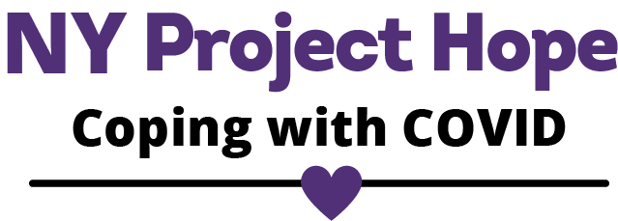

Here to talk | Here to listen | Here to support

NY Project Hope Media Kit

NYProjectHope.org

A program of the NYS Office of Mental Health
Funded by the Federal Emergency Management Agency
Administered by the Substance Abuse and Mental Health Services Administration

Here to talk | Here to listen | Here to support
Dear Community Partner:
NY Project Hope, a statewide initiative of the New York State Office of Mental Health, helps New York residents navigate the changes caused by COVID-19. Will you consider sharing information about our free, confidential crisis counseling services throughout your organization?
What is NY Project Hope?
NY Project Hope is a FEMA-funded program that provides crisis counseling and public education for NY residents in response to the COVID-19 pandemic. We offer an Emotional Support Helpline staffed by trained crisis counselors who help callers talk through their emotions and find resources to help them cope with the challenges of COVID. NY Project Hope also has digital educational materials, a supportive social media presence, and a website filled with resources and relevant materials that folks can access anytime at www.nyprojecthope.org. We also welcome you to take a look – and follow - our Facebook, Instagram, and Twitter. Our services are always confidential, free, and anonymous.
Inside you will find media tools and resources that you are welcome to copy, paste, and share to tell your group about our services.
Thank you for your support.
The team at New York Project Hope

Crisis Counseling Program Offers Free, Confidential Support During COVID-19

NY Project Hope helps New York understand their reaction and emotions during the COVID-19 pandemic. Through an emotional support helpline, educational materials, and trusted referrals, NY Project Hope supports people so they can manage the changes brought on by COVID-19.
Whether you want to learn about reliable community resources that can help you or you just want to talk ... maybe it's both. Whatever it is that you need as you work to navigate your way through these very unusual times, NY Project Hope is here for you during COVID-19. If you decide to call our Emotional Support Helpline, you will reach someone who has been trained to hear what you are saying and give you the kind of support that works best for you during the pandemic...whether it's coping strategies, resources or a chance to talk - the call is always free, confidential, and anonymous. NY Project Hope’s Emotional Support Helpline number is 1-844-863-9314. Trained crisis counselors are available every day from 8am to 10pm. For coping tips, relaxation exercises and much more, log onto NY Project Hope’s website, NYProjectHope.org
# # #

Newsletter Article

.

Website Listing & QR Code

NY Project Hope Emotional Support Helpline: 1-844-863-9314
NY Project Hope is the statewide crisis counseling response to COVID-19. Helpline callers can reach a trained crisis counselor seven days a week from 8am to 10pm. The calls are free, confidential, and anonymous. New Yorkers can also visit NY Project Hope’s website to find resources, strategies, and tips to help cope during COVID. NY Project Hope is a program of the NYS Office of Mental Health and is funded by FEMA.

Sample copy: NY Project Hope helps New Yorkers understand their reaction and emotions during the COVID-19 pandemic. Through an emotional support helpline, educational materials, and trusted resources, NY Project Hope helps people manage the changes brought on by COVID-19. Visit www.NYprojecthope.org to learn more.
Social Media Posts

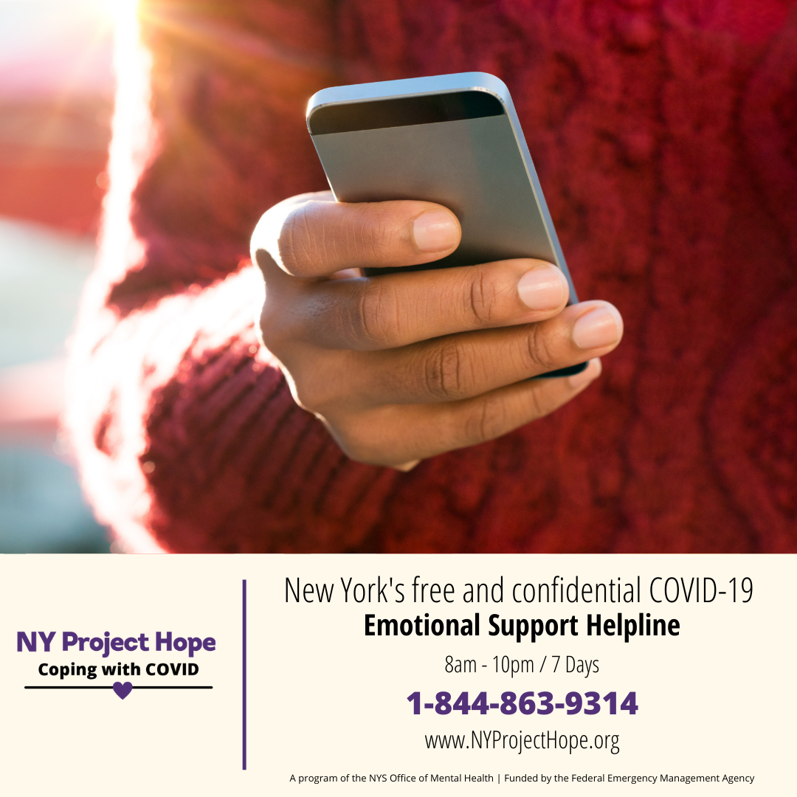
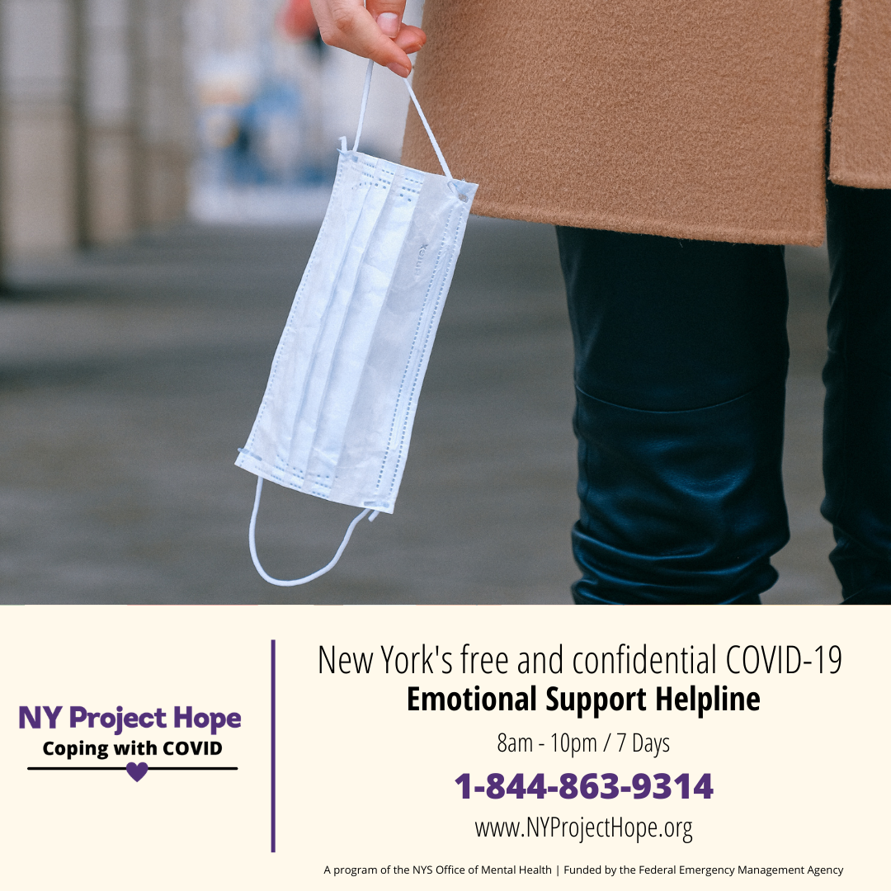

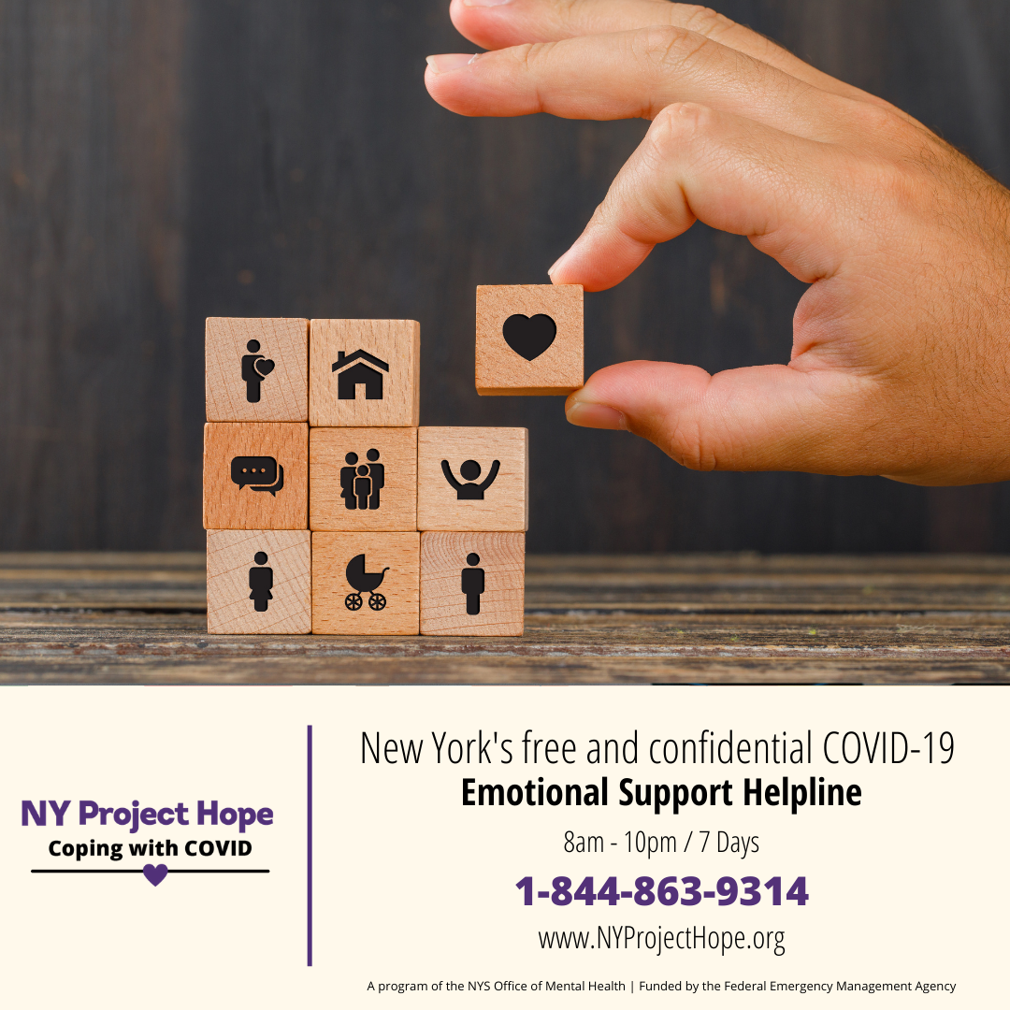

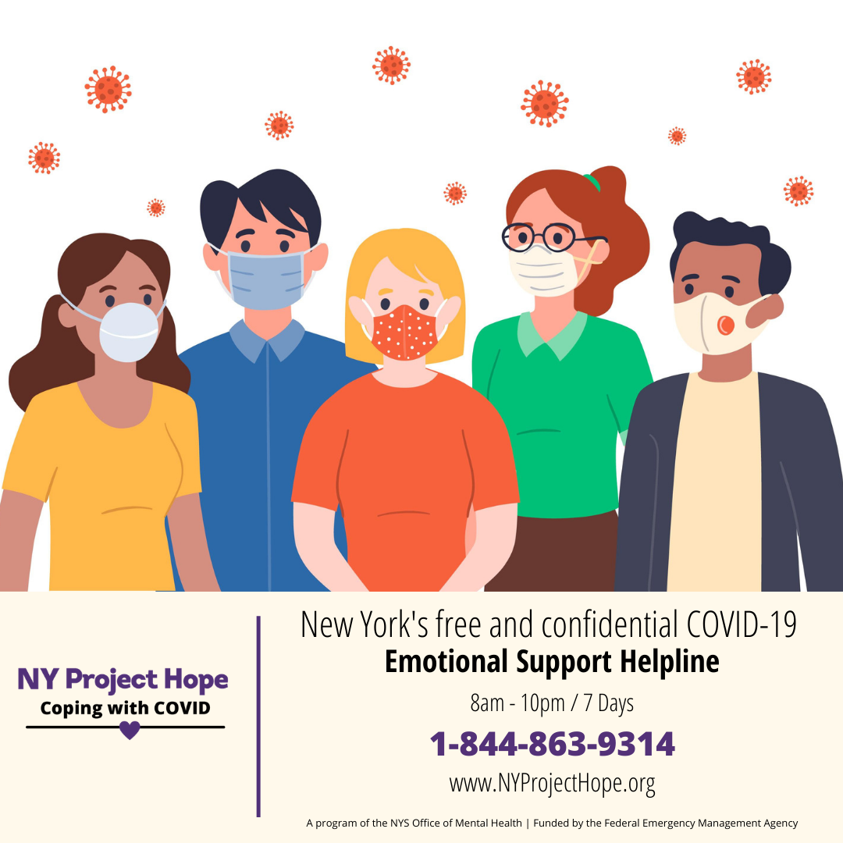
_______________________________________________________________
We also provide virtual public education sessions.
Contact Cheryl.Gerstler@omh.ny.gov
for more information or to schedule your session!
The team at NY Project Hope is grateful for your support!

