Compensation Equity for Librarians

Summary: Librarians request that their compensation and obligation schedules better conform to the expectations articulated in the SUNY Board of Trustees Policy Guidelines and the UUP Agreement with New York State.

I. The definitions section of the SUNY Policies of the Board of Trustees clarifies that librarians are “academic employees” with “academic rank.”
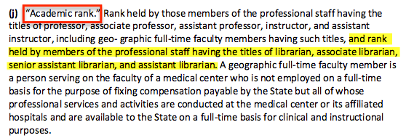

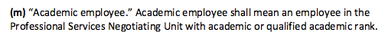

II. Article 20 of the UUP Agreement with New York State demonstrates that librarian ranks (e.g.“Senior Assistant Librarian”) directly correlate to the ranks held by professors (e.g. “Assistant Professor”).

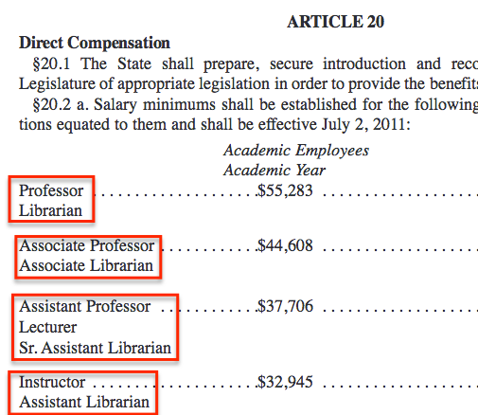

III. The direct compensation rates listed in Article 20 of the UUP Agreement establish a clear distinction between rates for academic employees with “academic year” obligations and those with “calendar year” obligations.

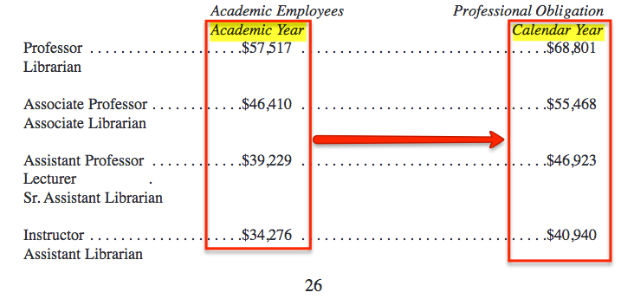

IV. The tables in Article 20 of the UUP Agreement show that pay rates for academic employees with calendar year obligations are expected to be roughly 19.5% higher than those with academic year obligations at the same rank.

V. SUNY Cobleskill librarians are academic employees with “calendar year” obligations. As such—according to the UUP Agreement—our salaries should be roughly 19.5% higher than those earned by similarly ranked academic employees working “academic year” contracts.

V. Currently, however, SUNY Cobleskill librarians’ salaries for 12-month contracts are roughly equivalent to those earned by other academic employees with only 10-month obligations.

VI. Past practice at SUNY Cobleskill appears to acknowledge that salaries should differ for 10-month and 12-month academic employees at the same rank. Public salary data collected from the SeeThroughNY website (http://seethroughny.net/payrolls) shows multiple cases when salary adjustments accompanied shifts from one contract term to another. For instance, when Karl Schwarzenegger went from a 12-month contract to a 10-month contract in 2014, his salary was lowered by 17.6%. Likewise, when John Kowal went from a 10-month contract to a 12-month contract in 2012, his salary increased by 21.2%.

VII. Librarians recognize that responsibilities differ among academic units on campus and support the statement in the SUNY Cobleskill faculty handbook that

Because of the diversity of requirements and demands arising from different programs and courses, it is not feasible to attempt to specify in terms of numbers of hours, students, and preparations, what an academic employee's workload should be. (SUNY Cobleskill Faculty Handbook, p. 45)

Even within the library, different positions have different obligations. Work flow is determined by functional responsibilities. Certain positions within the library require a 12-month presence on campus; others—more closely dependent on student presence—require only a 10-month presence. In either case, however, we believe our pay scale should be on par with that of other academic employees. In practice, that means a 10-month salary for an academic calendar obligation or a 12-month salary for a calendar year obligation. At present, we are receiving a 10-month salary for 12-months worth of work, which is at odds with the principles communicated in the SUNY Board of Trustees Policy Guidelines and the UUP Agreement with New York State.

Proposal: Our proposal is that the pay rates and obligation calendars be reconsidered on an individual basis by the Library Dean and Library Faculty to determine a solution that meets the needs of the library and the campus community while providing equitable compensation for the librarians. For those in positions where a 10-month presence would suffice, obligation calendars would be switched to the 10-month academic year calendar while the current salary rate remained in effect. For those in positions requiring a 12-month presence for the continued smooth operation of the library, a salary adjustment would be granted corresponding to the 19.5% increase articulated in Section 20 of the UUP Agreement.
So to recap:
- According to the SUNY Board of Trustees Policies, librarians are academic employees with academic ranks corresponding to disciplinary faculty;
- According to the UUP Agreement, negotiated salary minimums for academic employees with 12-month contracts are to be 19.5% higher than those of academic employees with 10-month contracts;
- At SUNY Cobleskill, librarians’ salaries for calendar year contracts are roughly equivalent to those of other academic employees working academic year contracts—meaning we’re doing 12 months’ work for 10 months’ pay;
- Some librarians need to be here year-round; others could shift to 10-month contracts;
- We want the flexibility to choose either 10 months’ work for 10 months’ salary OR 12 months’ salary for 12 months’ work—as required by the workflow or our particular job.

